FrSky 2.4GHz Radio Control System
Instruction Manual for TF Receivers
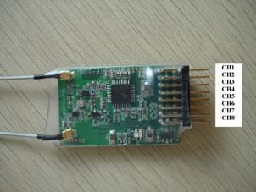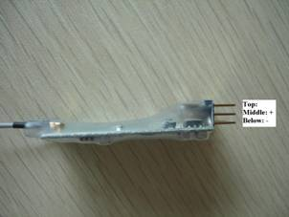

- TF Receivers
Read the instruction manual and set up the devices as described below.

1.1 Compatibility:
Futaba: TM7, TM8, TM10, TM14, etc.
FrSky: TF-8M, TF-14M

1.2 Specifications:
Model: TFR8
Number of channel: 8
Operating Voltage Range: 4V~10V
Dimension: 53mm*30mm*11mm
Weight: 13.5g

- Setup

2.1 Bind procedure:
Turn on the transmitter, connect the battery to the receiver while pressing receiver’s F/S button. After the RED LED is off and GREEN LED is solid, the binding process is completed and working mode is activated.

2.2 Setting failsafe:
TF series receivers support failsafe function for all channels.
After the receiver has been bind, press briefly the F/S button of the receiver, the GREEN LED of the receiver will flash twice, the failsafe is set up successfully.
If you do not need the failsafe function any more, just re-bind the receiver to default failsafe mode.

2.3 LED status:
RED LED | GREEN LED | Mode
Off | On | Working mode
On | On | Waiting to be bind
Flash | On | Signal lost
On | Flash twice | Set failsafe

Should you have any questions or need further queries, pls send e-mails to us.
Technical support: frsky@frsky-rc.com or sales4tech@gmail.com.

